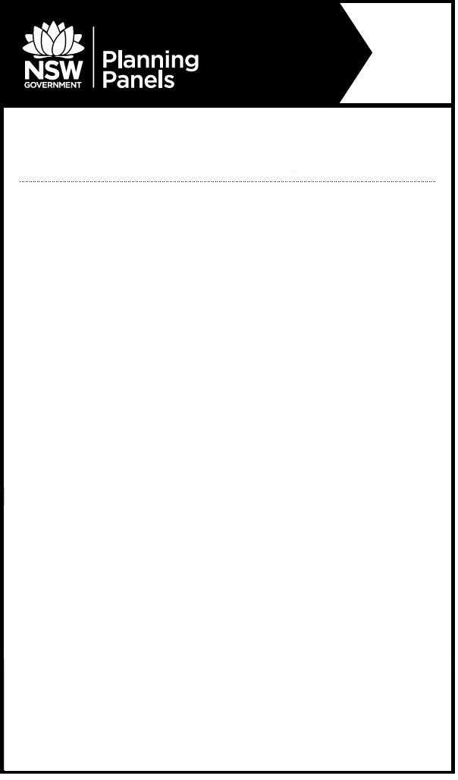

**Notice of Public Meeting**

**Southern Regional** **Planning Panel**

The panel will meet to determine the following:

* PPSSTH-149 – Wagga Wagga – DA22/0122 – 1268 Oxley Bridge Road URANQUINTY 2652 - Electricity Generating Works – Solar Farm

**When:** **Wednesday, 16th November 2022 at 10:30am**

**Where: The meeting will be held by public videoconference (dial in option available).**

Relevant documents will be available on the Planning Panels website [www.planningportal.nsw.gov.au/planningpanels](http://www.planningportal.nsw.gov.au/planningpanels) at least seven days before the meeting.

To register to speak or to listen to this meeting, please contact the Planning Panels Secretariat **before 4pm on Monday, 14 November 2022** on 02 8217 2060 or email [enquiry@planningpanels.nsw.gov.au](mailto:enquiry@planningpanels.nsw.gov.au).

On registration you will be provided with a link to enable you to join the public videoconference, and a phone number and code should you wish to join by telephone (audio only).

Any person may listen to the public teleconference.

The panel is required to make an audio record of the meeting and make the recording publicly available on the Planning Panels website. You should be aware that this may include your personal information if you are presenting to the panel.

**For more information:** (02) 8217 2060

www.planningportal.nsw.gov.au/planningpanels